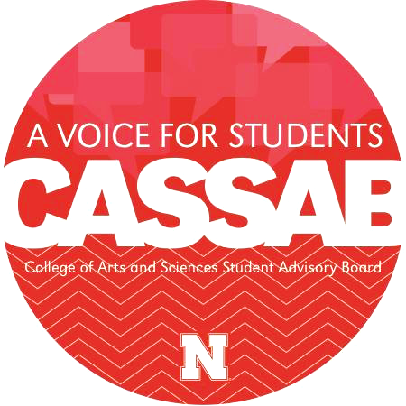
CASSAB Mission: To serve as a liaison between students in the College of Arts and Sciences and the Administration of the College by advocating for students’ interests and perspectives.
Large-Cap Fund Application

This fund is provided by the College of Arts and Sciences through CASSAB. The goal of the fund is to monetarily support Registered Student Organizations (RSOs) that make an impact on students of the College by contributing to the rich and multifaceted student life experience through experiential opportunities and academic engagement. Applicants may request an amount anywhere from $201 to $1000 in funding to meet their organization’s goals. The CASSAB Fund Allocation Board may either fully or partially fund requests when allocating resources. Applications are reviewed the first Thursday of each month and are accepted on a rolling basis. Please plan accordingly.

RSO: SOFS #:
Faculty/Staff Advisor: Advisor Email:
RSO Point of Contact Name: POC Position:
POC Email: POC Phone Number:
RSO Budget (For Academic Year): Average # of Attendees at Meetings/Events:
Total # of Registered Members: # of Active Members:
Average Attendee # at Activities/Events (If different than active member #):
Projected Attendee # at this Activity/Event (If different than active member #):

1. Describe your RSO’s affiliation with the College of Arts and Sciences. (30-150 words)

2. Name & Date of Event, Activity, or Program:
Provide details. How will the RSO use funding to impact students and the UNL community? How will this enhance the reputation of the College of Arts and Sciences? If your request involves an event, be explicit in the goal and the impacts of a successful event. (150-250 words

3. Total Funding Amount Requested: $
Provide a detailed budget outlining what the money will be used for (i.e. $20 for drinks, $60 for pizza, $100 for guest speaker, etc.). Itemize materials needed and their costs. The more detail provided, the easier it is for the Board to allocate money to financially support your your RSO. The amount requested may be between $201-$1000. (150-250 words)

Organization Name:
Contact Name:

Event Name:

Expenses
Site | Estimated | Actual | Difference
Room and Hall Fees
Site Staff
Equipment
Tables/Chairs/Stage
Other
Subtotals
Expenses | Estimated | Actual | Difference
Performers
Speakers
Travel
Hotel
Other
Subtotals

Decorations | Estimated | Actual | Difference
Flowers
Candles
Lighting
Balloons
Paper Supplies
Other
Subtotals
Food | Estimated | Actual | Difference
Food
Beverages
Staff and Gratuities
Linens/Dishes/Utensils
Other
Subtotals

Publicity | Estimated | Actual | Difference
Graphic Design
Photocopying/Printing
Advertisements
Other
Subtotals

4. Is there any other information you feel the committee should know? (If not, it is okay to leave this section blank). (0-250 words)

The college would like to promote your event. Please send details about the event regarding the time, place, and a brief description and notify the Fund Allocation Board if there is a change.

The College of Arts and Sciences Student Advisory Board would like the RSO to present the proposal to the general board. This presentation can be in any format that would help convey the interests in our funds (PowerPoint, video, or speech etc.) Please see the below prompts that should be addressed.
There will be 4 criteria spread across 5-7 minutes. Please take some time to consider the 4 criteria:
- Background- What is your organization? History? Leadership? Current funding?
- Impact of Event - Who and what is your impact? What do you plan to do?
- A motive of Funding - Why do you need this funding for your event?
- Relevancy to the College of Arts and Science- How is this request relevant to our college? What do we offer for your organization?
Depending on the need of your funding request, the board will schedule a time and date for you to present.

Our RSO will provide CASSAB the follow-up requested in return for sponsorship.
Our RSO will include the CASSAB design on all advertisements for the sponsored activity.

Advisor Signature: Date:

