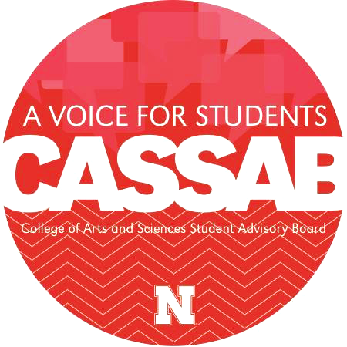
CASSAB Mission: To serve as a liaison between students in the College of Arts and Sciences and the Administration of the College by advocating for students’ interests and perspectives.
Small-Cap Fund Application

This fund is provided by the College of Arts and Sciences through CASSAB. The goal of the fund is to monetarily support Registered Student Organizations (RSOs) that make an impact on students of the College by contributing to the rich and multifaceted student life experience through experiential opportunities and academic engagement. Applicants may request an amount anywhere from $1 to $200 in funding to meet their organization’s goals. The CASSAB Fund Allocation Board may either fully or partially fund requests when allocating resources. Applications are reviewed the first Thursday of each month and are accepted on a rolling basis. Please plan accordingly.

RSO: SOFS #:
Faculty/Staff Advisor: Advisor Email:
RSO Point of Contact Name: POC Position:
POC Email: POC Phone Number:
RSO Budget (For Academic Year): Average # of Attendees at Meetings/Events:
Total # of Registered Members: # of Active Members:
Average Attendee # at Activities/Events (If different than active member #):
Projected Attendee # at this Activity/Event (If different than active member #):

1. Describe your RSO’s affiliation with the College of Arts and Sciences. (30-150 words)

2. Name & Date of Event, Activity, or Program:
Provide details. How will the RSO use funding to impact students and the UNL community? How will this enhance the reputation of the College of Arts and Sciences? If your request involves an event, be explicit in the goal and the impacts of a successful event. (150-250 words

3. Total Funding Amount Requested: $
Provide a detailed budget outlining what the money will be used for (i.e. $20 for drinks, $60 for pizza, $100 for guest speaker, etc.). Itemize materials needed and their costs. The more detail provided, the easier it is for the Board to allocate money to financially support your your RSO. The amount requested may be between $1-$200. (150-250 words)

Organization Name:
Contact Name:

Event Name:

Expenses
Site | Estimated | Actual | Difference
Room and Hall Fees
Site Staff
Equipment
Tables/Chairs/Stage
Other
Subtotals
Expenses | Estimated | Actual | Difference
Performers
Speakers
Travel
Hotel
Other
Subtotals

Decorations | Estimated | Actual | Difference
Flowers
Candles
Lighting
Balloons
Paper Supplies
Other
Subtotals
Food | Estimated | Actual | Difference
Food
Beverages
Staff and Gratuities
Linens/Dishes/Utensils
Other
Subtotals

Publicity | Estimated | Actual | Difference
Graphic Design
Photocopying/Printing
Advertisements
Other
Subtotals

4. Is there any other information you feel the committee should know? (If not, it is okay to leave this section blank). (0-250 words)

The college would like to promote your event. Please send details about the event regarding the time, place, and a brief description and notify the Fund Allocation Board if there is a change.

Our RSO will provide CASSAB the follow-up requested in return for sponsorship.
Our RSO will include the CASSAB design on all advertisements for the sponsored activity.

Advisor Signature: Date:

