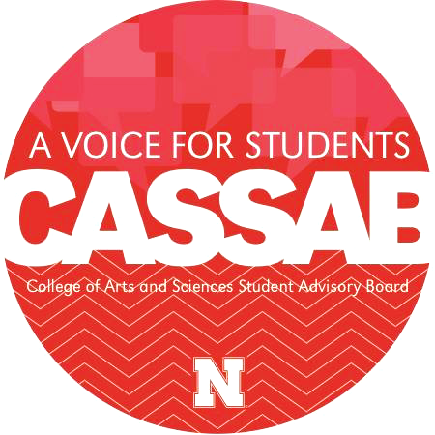
CASSAB Mission: To serve as a liaison between students in the College of Arts and Sciences and the Administration of the College by advocating for students’ interests and perspectives.
Fund Allocation Application

This fund is provided by the College of Arts and Sciences through CASSAB. The goal of the fund is to monetarily support Registered Student Organizations (RSOs) that make an impact on students of the College by contributing to the rich and multifaceted student life experience through experiential opportunities and academic engagement. Applicants may request an amount anywhere from $100 to $750 in funding to meet their organization’s goals. The CASSAB Fund Allocation Board may either fully or partially fund requests when allocating resources. Applications are reviewed the first Thursday of each month and are accepted on a rolling basis. Please plan accordingly.

RSO: SOFS #:
Faculty/Staff Advisor: Advisor Email:
RSO Point of Contact Name: POC Position:
POC Email: POC Phone Number:
RSO Budget (For Academic Year): Average # of Attendees at Meetings/Events:
Total # of Registered Members: # of Active Members:
Average Attendee # at Activities/Events (If different than active member #):
Projected Attendee # at this Activity/Event (If different than active member #):

1. Describe your RSO’s affiliation with the College of Arts and Sciences. (30-150 words)

2. Name & Date of Event, Activity, or Program:
Provide details. How will the RSO use funding to impact students and the UNL community? How will this enhance the reputation of the College of Arts and Sciences? If your request involves an event, be explicit in the goal and the impacts of a successful event. (50-250 words)

3. Discuss your RSO’s annual budget. Include information about the balance of the RSO’s SOFS account, membership dues, any indirect or direct external funding the RSO receives, and/or additional information about the budget you feel is relevant to this application. (50-250 words)

4. Total Funding Amount Requested: $
Provide a detailed budget outlining what the money will be used for (i.e. $20 for drinks, $60 for pizza, $100 for guest speaker, etc.). Itemize materials needed and their costs. The more detail provided, the easier it is for the Board to allocate money to financially support your your RSO. The amount requested may be between $100-$750. (50-250 words)

Example:
Total Funding Amount Requested: $___565.00____
$260.04 for Valentino’s Pizzas (approximately 98 servings)
$243.00 12 16” Large Valentino’s Signature Pizzas ($20.25 per pizza, including taxes)
$17.04 1 9” Gluten-free Valentino’s Signature Pizzas
$53.53 for Pepsi beverages (96 servings)
$26.67 1 case Mountain Dew 36-12 oz. cans
$8.38 2 cases Aquafina bottled water 12-12 oz. bottles ($4.19 per case)
$18.48 2 cases Gatorade Variety Pack 18-12 oz. bottles ($9.24 per case)
$150 for DJ ($50 per hour x 3 hours)
$102.72 for 12 event t-shirts through Underground Printing ($8.56 per shirt x 12 shirts)
Total estimated cost: $566.29

5. Is there any other information you feel the committee should know? (If not, it is okay to leave this section blank). (0-250 words)

If funding is granted, CASSAB requires follow-up from the RSO in the form of a paragraph on social media. Include: How? What? When? Impact?
Send this and a picture of the sponsored activity to CASSAB through Facebook within one week of the event. If the event date changes from what is listed above, please notify us at cassab@unl.edu.

Our RSO will provide CASSAB the follow-up requested in return for sponsorship.
Our RSO will include the CASSAB design on all advertisements for the sponsored activity.

Advisor Signature: Date:

Questions or concerns? Email us at cassab@unl.edu
Thank you for your application!

